# Exercise: Selenium Basics

This document defines the homework assignments from the [QA Automation" Course @ Software University](https://softuni.bg/trainings/2550/qa-automation-may-2020).

Please submit as homework a single zip / rar / 7z archive holding the source code or whatever approach is needed to finish your tasks.

# Selenium

## Google Search

* Write a **test** that **opens a browser** and navigates to **http://www google.com**
* Then **searches** for the automation tool "**selenium**"
* Click on the **first result link**  and check if the browser will open [**http://www.seleniumhq.org**](http://www.seleniumhq.org)
* **Assert** that the title is **"Selenium - Web Browser Automation"**

### Examples

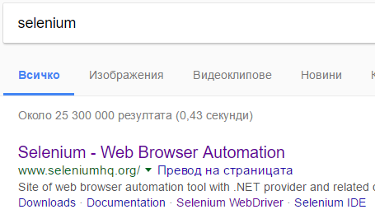

## QA Automation

* Write a **test** that **opens a browser** and navigates to [**http://www.softuni.bg**](http://www.softuni.bg)
* Then by using the **navigation bar,** navigate to the **QA Automation course page**
* **Assert** that there is a heading tag **<h1>** and it contains **"QA Automation - май 2020"**

### Examples

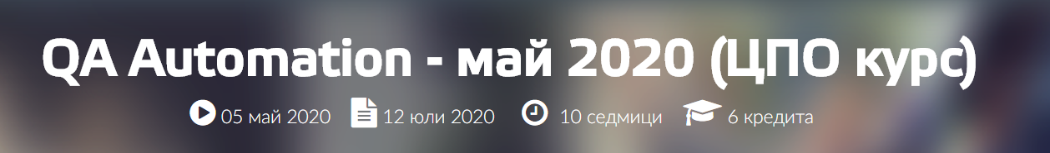

## Automation Practice Registration

Write a **test** that executes the following steps given below:

* Opens Chrome
* Navigates to <http://automationpractice.com/index.php>
* Clicks "Sign In"
* Enters a valid email in the **"Create an Account"** section
* Clicks "Create an account"
* Validates that the **same email** is set to the **email's field** in the **registration** **form**

### Examples

